Place: Nyirád, MOTORSPORT CENTRUM
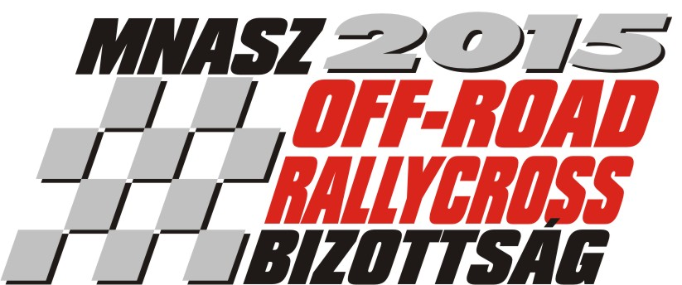
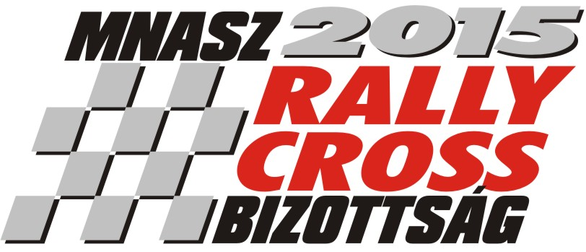
Date: 06-07.06.2015.

ENTRY FORM

Start Nr.: |  | Division: |  | Category:

 | Competitor: | Driver:
Name:
Address (with ZIP code):
Phone:
E-mail:
Licenc Nr:
Representative of the competitor: |  | Paddock:

A versenygépkocsi adatai

Make/Model: |  | Chassis Nr.: |  | FIA Homologation Nr.:

ccm:  Turbo: yes / no |  | Division: |  | 4wd / 2wd

The signer recognizes the rules of the Hungarian Rallycross Standard Regulations and Supplementary Regulations and undertakes to strictly observe them. By signing the entry form the driver consent to be implemented during the race, alcohol and drug test.He confirms that the statements made on this entry form are correct and that the entered car conforms with the current conditions of the Int. Sporting Code, Appendix J of the FIA.

Date: | Signature competitor: | Signature driver:

